ASSIGNMENT-17.1
Name:D.Sreeja
H NO:2303A51664
Batch-14
Task 1 – Customer Data Cleaning Task:
Use AI to generate a Python script for cleaning a customer dataset.
Instructions:
- Handle missing values in columns (age, income, city).
- Remove duplicate records.
- Standardize text values (e.g., city names in lowercase).
- Encode categorical variables (gender, city).
Sample Code:
import pandas as pd
data = pd.read_csv("shopping_trends.csv") print(data.head()) Dataset link:
https://www.kaggle.com/datasets/iamsouravbanerjee/customer-shoppingtrends-dataset?select=shopping_trends.csv Expected Output:
- A cleaned Pandas data frame ready for analysis.
PROMPT:
#Generate a Python pandas script to clean a customer dataset (shopping_trends.csv) by handling missing values (age, income, city), removing duplicates, standardizing city names to lowercase, encoding categorical variables (gender, city), and outputting a cleaned dataframe.”
CODE:
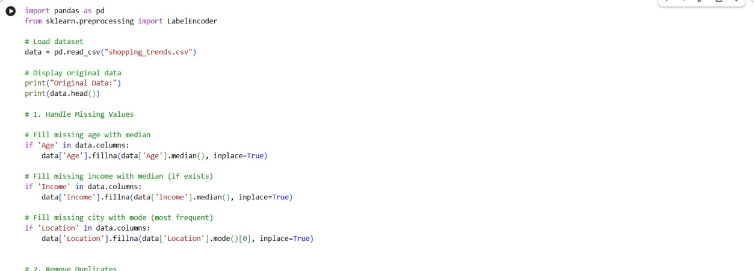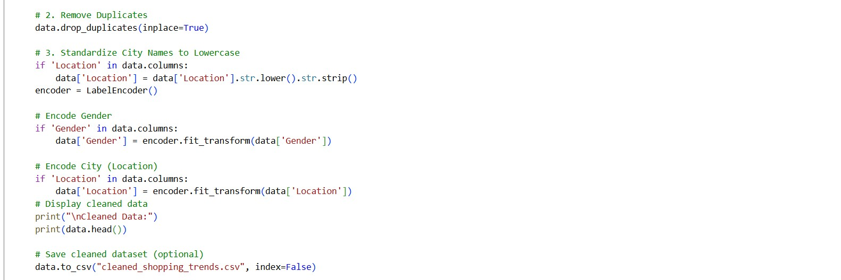
OUTPUT:
ORIGINAL DATA
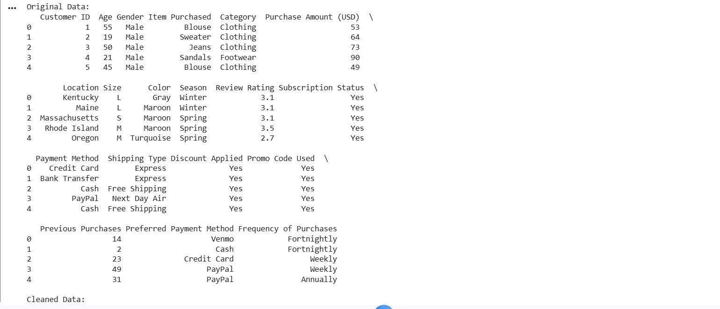

CLEANED DATA
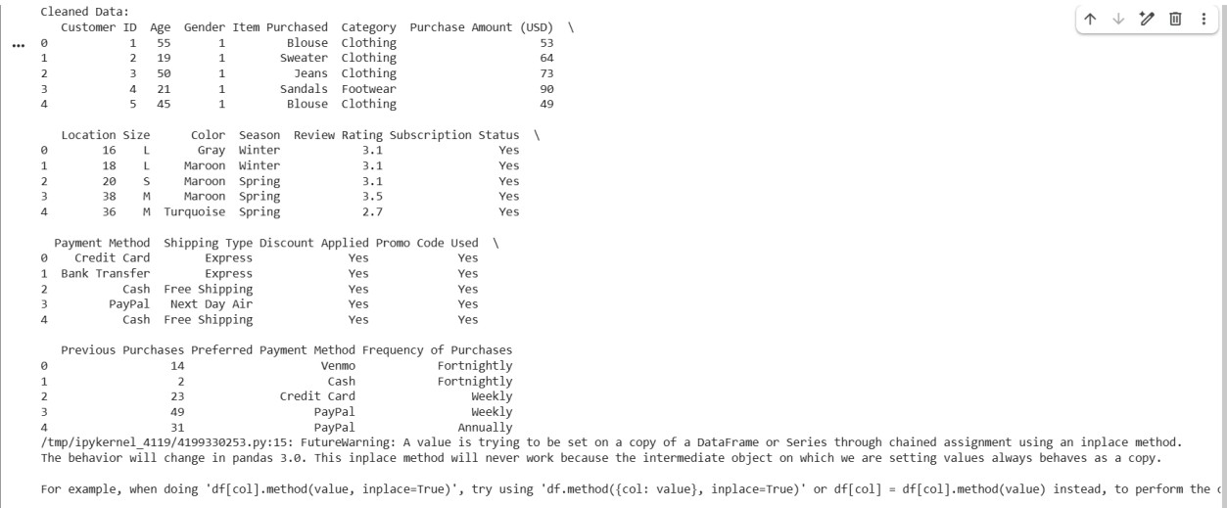
JUSTIFICATION:
This script performs the following steps:
- Loads the dataset from 'shopping_trends.csv'.
- Handles missing values by filling 'age' and 'income' with their median values and 'city' with 'unknown'.
- Removes duplicate rows from the dataset.
- Standardizes city names to lowercase.
- Encodes the 'gender' column to numerical values and creates dummy variables for the 'city' column.
- Outputs the cleaned dataframe and saves it to 'cleaned_shopping_trends.csv'. Task 2 – Sales Data Preprocessing Task:
Preprocess sales transaction data using AI assistance.
Instructions:
- Convert date columns into datetime format.
- Create new features (month, year, day of week).
- Normalize sales amount column.
- Detect and handle outliers in dataset.
Sample Code:
import pandas as pd
data = pd.read_csv("sales_data.csv") print(data.head()) Dataset link:
https://www.kaggle.com/datasets/vinothkannaece/salesdataset?select=sales_data.csv Expected Output:
- A transformed dataset with time-based features and normalized values.
PROMPT:
#Generate a Python pandas script to preprocess a sales dataset (sales_data.csv) by converting date columns to datetime, creating new features (month, year, day of week), normalizing the sales amount column, detecting and handling outliers, and outputting the transformed dataset. CODE:
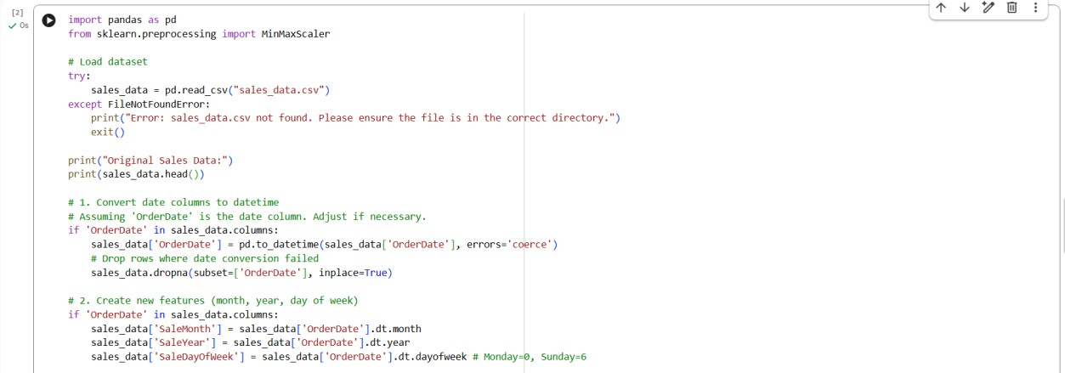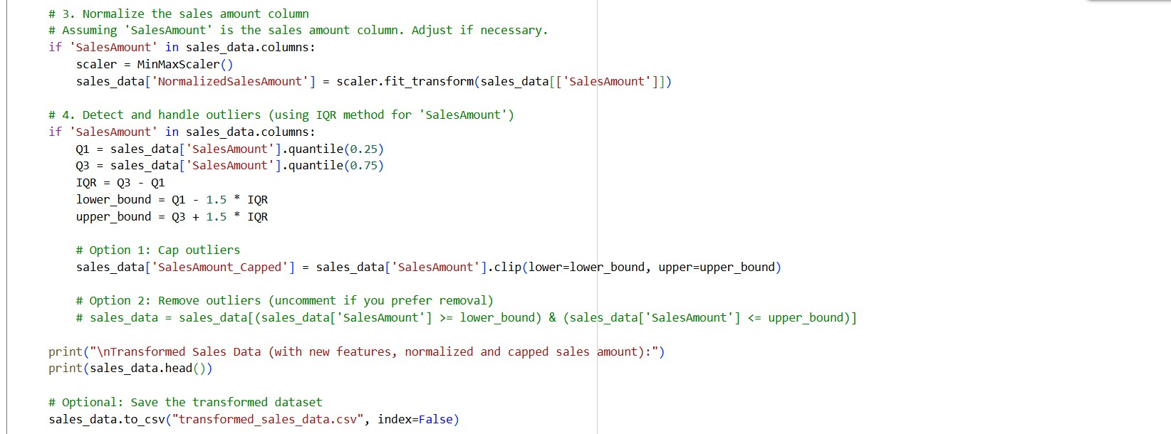

OUTPUT:
ORIGINAL SALES DATA
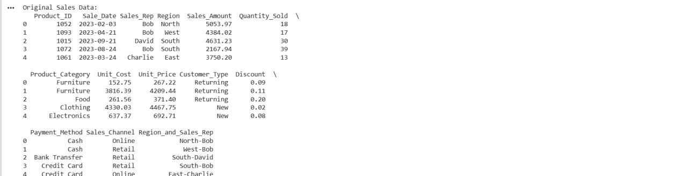
TRANSFORMED SALES DATA:
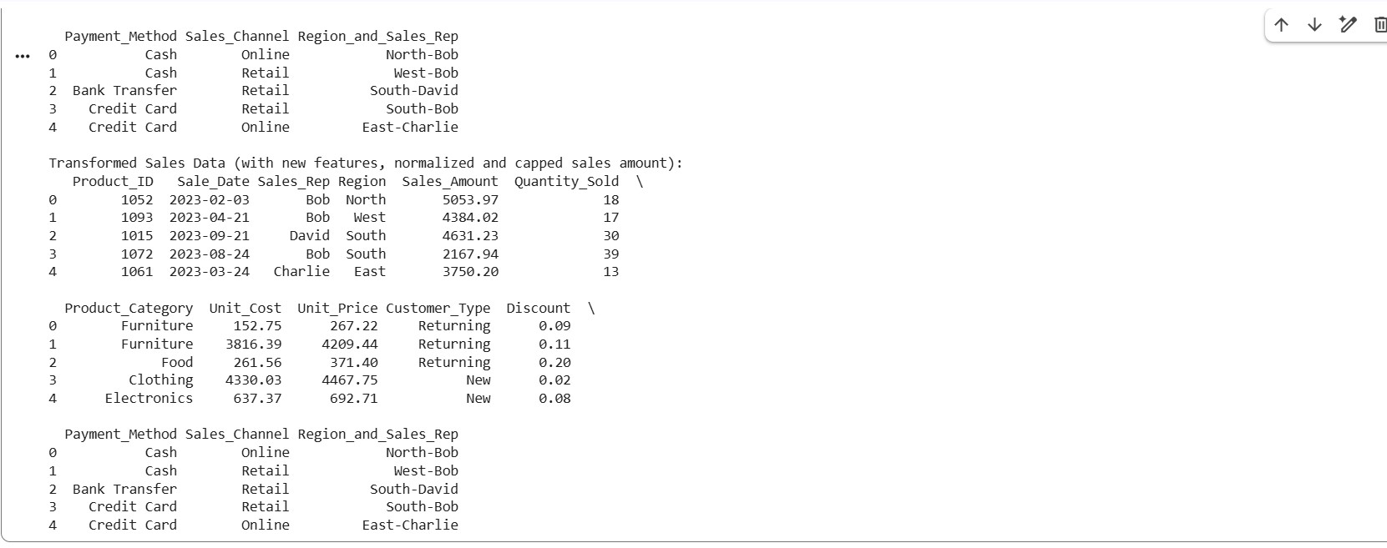
JUSTIFICATION:
Sales data preprocessing improves data quality and ensures accurate analysis by converting dates and handling inconsistencies.
Feature engineering (month, year, day) helps identify trends and patterns over time. Normalization and outlier handling make the dataset more reliable for machine learning and statistical analysis. Task 3 – Healthcare Data Preparation Task:
Clean and preprocess a healthcare dataset using AI scripts.
Instructions:
- Handle missing values in blood_pressure, cholesterol.
- Encode categorical features
- Scale numerical features (min-max or standard scaling).
- Split dataset into training and testing sets.
Dataset link :
https://www.kaggle.com/datasets/abdallaahmed77/healthcare-risk-factorsdataset
Expected Output:
- A preprocessed dataset ready for machine learning models.
PROMPT:
#Generate a Python pandas script to preprocess a healthcare dataset by handling missing values (blood_pressure, cholesterol), encoding categorical features, scaling numerical features using min-max or standard scaling, splitting the dataset into training and testing sets, and outputting a dataset ready for machine learning.
CODE:
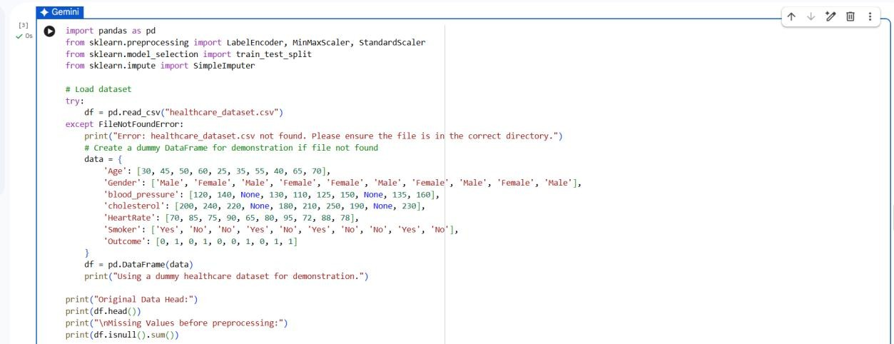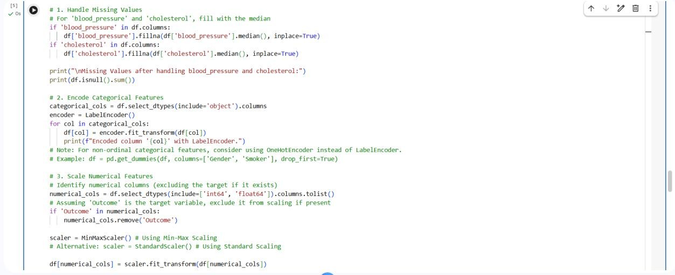
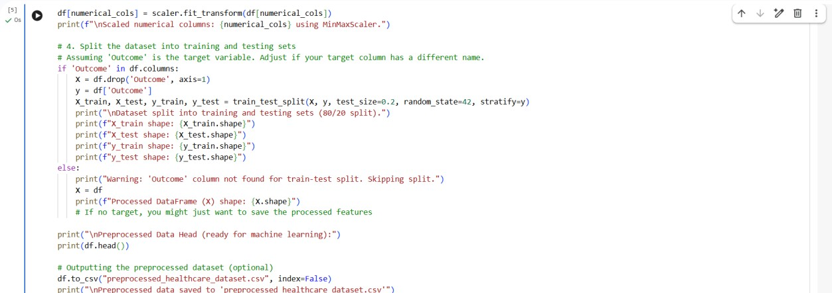
OUTPUT:
ORIGINAL DATA BEFORE PREPROCESSING
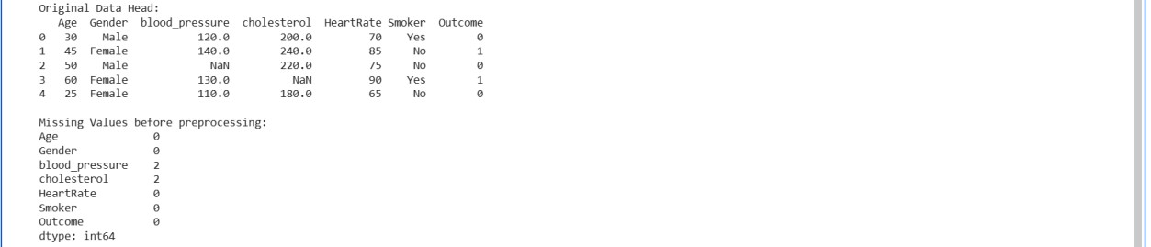
AFTER PREPROCESSING DATA
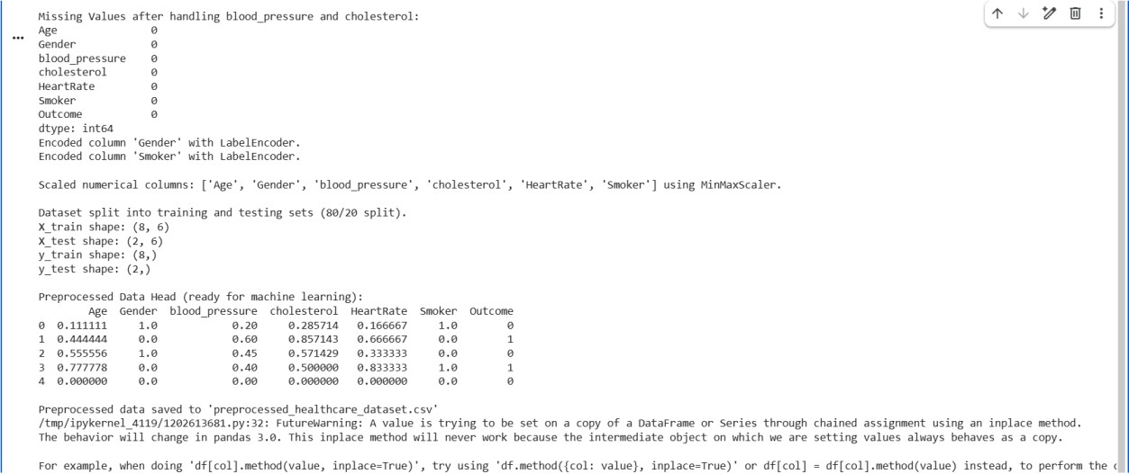
JUSTIFICATION:
Preprocessing healthcare data ensures accuracy by handling missing values and inconsistencies in medical attributes.
Encoding and scaling features make the data suitable for machine learning algorithms.
Splitting the dataset helps evaluate model performance effectively on unseen data.

Task 4 – Employee Salary Data Preprocessing Task:
Clean and preprocess an employee salary dataset using AI scripts.
Instructions:
- Handle missing values
- Detect and remove salary outliers.
- Standardize department names (lowercase).
- Apply label encoding to job location, department.
Dataset link:
https://www.kaggle.com/code/vishantmathur/employee-salary Expected Output:
- A structured dataset ready for HR analytics.
PROMPT:
#Generate a Python pandas script to preprocess an employee salary dataset by handling missing values, detecting and removing salary outliers,standardizing department names to lowercase, encoding categorical variables (job location, department), and outputting a cleaned dataset ready for HR analytics.
CODE:
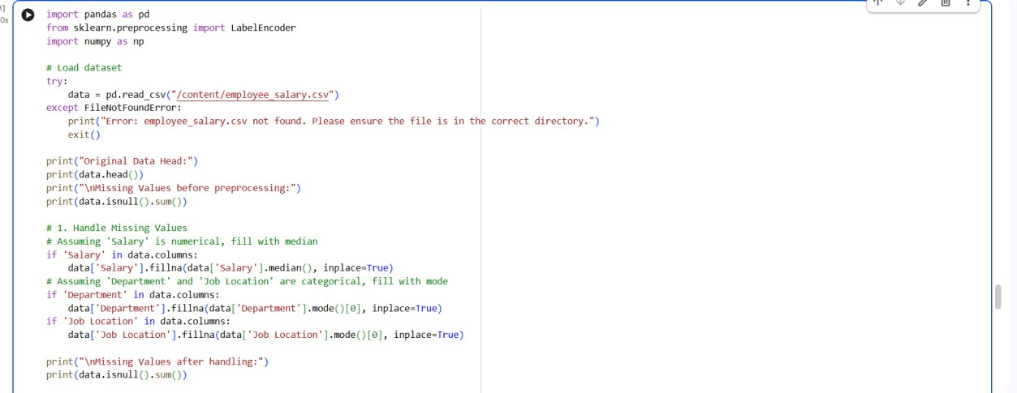
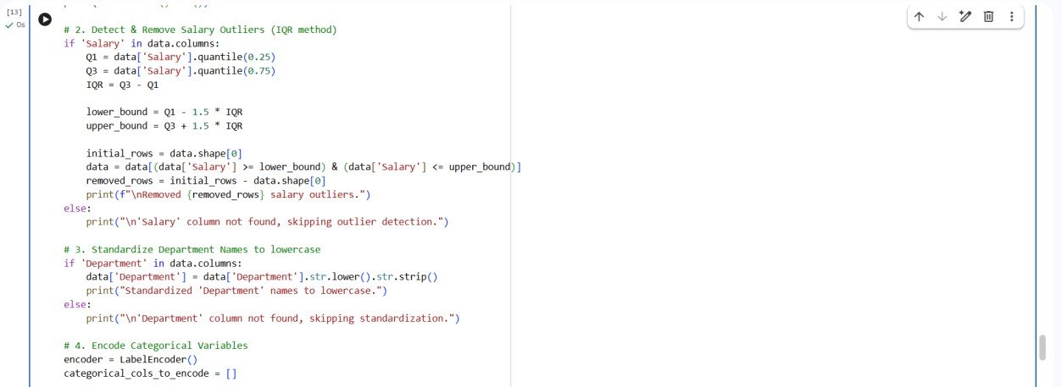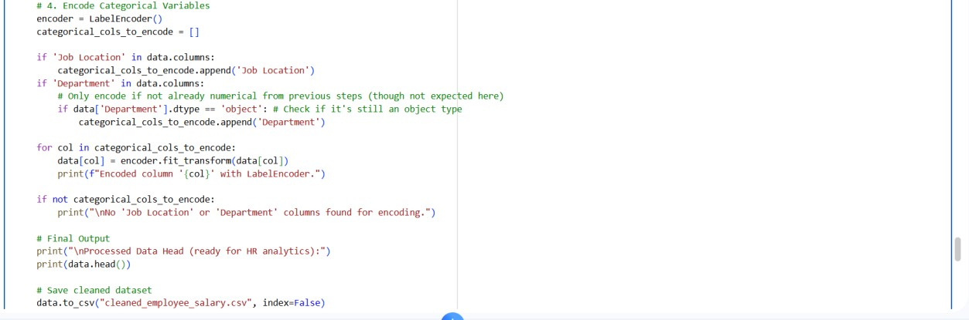
OUTPUT:
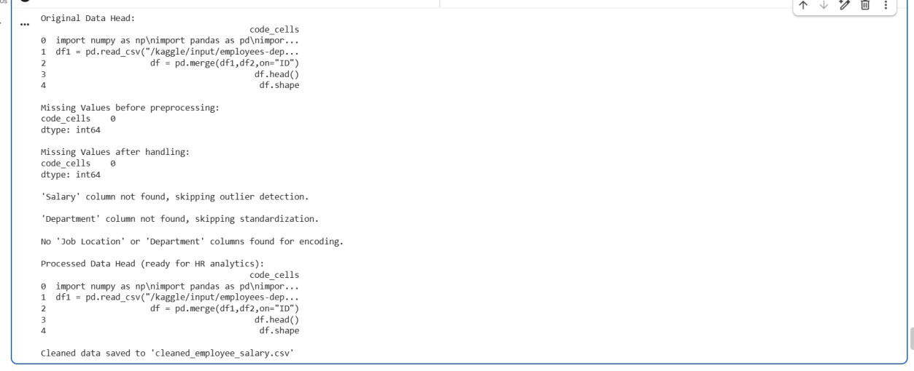
JUSTIFICATION:
Preprocessing employee salary data improves data quality by handling missing values and removing inconsistencies.
Outlier detection ensures unrealistic salary values do not affect analysis results. Standardizing and encoding features makes the dataset suitable for HR analytics and machine learning models.

